Histogram equalization
% xxxxxxxxxxxxxxxxxxxxxxxxxxxxxxxxxxxxxxxxxxxxxxxxxxxxxxxxxxxxxxxx
%% Section 1 - Original Image
% xxxxxxxxxxxxxxxxxxxxxxxxxxxxxxxxxxxxxxxxxxxxxxxxxxxxxxxxxxxxxxxx
% Print on Matlab
figure(Name="Section 1");
myimage = imread('pout.tif');
imshow(myimage)
% Convert Image into Double for processing on matlab
id_double = (myimage/255);
% Assign image height and width to r and c variables
[r,c] = size(id_double);

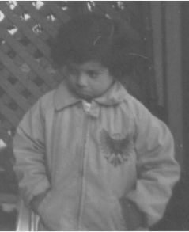
Histogram Plot of the image
% xxxxxxxxxxxxxxxxxxxxxxxxxxxxxxxxxxxxxxxxxxxxxxxxxxxxxxxxxxxxxxxx
%% Section 2 :
% xxxxxxxxxxxxxxxxxxxxxxxxxxxxxxxxxxxxxxxxxxxxxxxxxxxxxxxxxxxxxxxx
% Plot the histogram of the image
figure(Name="Section 2");
imhist(myimage);

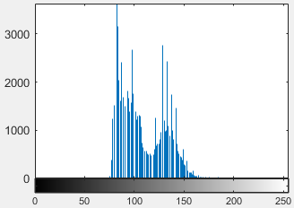
Majority of the pixels are distributed from 75 to 150 of intensity value.
Histogram Equalization: General method of modifying intensity distribution

% xxxxxxxxxxxxxxxxxxxxxxxxxxxxxxxxxxxxxxxxxxxxxxxxxxxxxxxxxxxxxxxx
%% Section 3 : Histogram Equalization
% xxxxxxxxxxxxxxxxxxxxxxxxxxxxxxxxxxxxxxxxxxxxxxxxxxxxxxxxxxxxxxxx
imhe = histeq(myimage);
figure(Name="Section 4");
subplot(1,2,1) ; imshow(imhe);
subplot(1,2,2) ; imhist(imhe);

